# Project brief

PoC: Starfinder player character creator

## Application concept

### Overview

This project is a proof of concept for a player character creator for the Starfinder RPG showing up the 4 pillars of OOP: abstraction, encapsulation, inheritance and polymorphism.

#### Reference examples

Some examples for player character creators came along with RPGs like

* Baldurs Gate
* Divinity: Original sins

### The application

#### Scenes in the project

There are four scenes for the application that provide a wizard that guides the user through the player character creation process:

1. Starting menu, where users can start to create a new player character and exit the character creator
2. Main player character definition, where the user can give a name, choose one of the predefined races, themes and character classes
3. Finalize ability scores, where the user can modify the attribute values of the chosen player character
4. Character summary, showing an overview of the created player character and the user can go back to the main menu

#### User Interactions

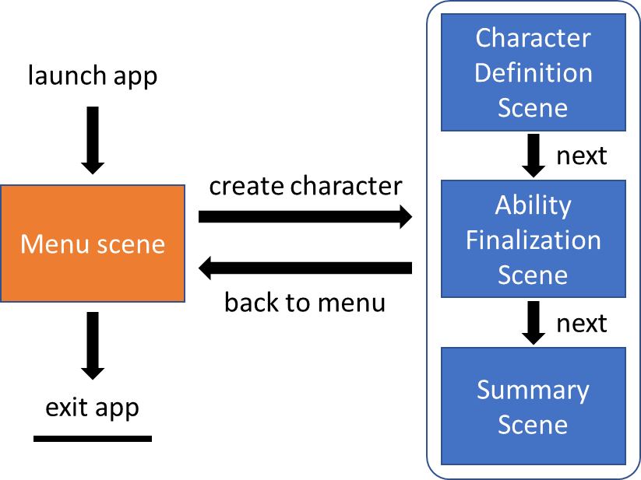

#### Basic functionality

The User needs to be able to:

* Start the character creation from the start menu scene
* Go to the next scene in the wizard till last wizard scene is reached
* Input data where needed in the scenes oft he wizard
* Return to the start menu from the last scene of the wizard
* Exit the app from the start menu scene

A new character is created with starting the creation process and the chosen data is persisted during the session of a character creation.

Based on the users input some character attributes will be calculated conform to the Starfinder rulebook in the last step of the creation process.

#### Object model

